Physical-to-Physical Migration

🌟 Definition
# Source: AI Source: Provided by: [Data Path: Persons Table -> ID Column: 1, Name_En Column: Motasem Essam] -> From: [ChatGPT] on [6/7/2026]
Physical-to-Physical (P2P) Migration is the process of moving applications, data, services, and configurations from one physical server to another physical server.
Both the source and destination servers are actual hardware machines.

🎯 Purpose
# Source: AI Source: Provided by: [Data Path: Persons Table -> ID Column: 1, Name_En Column: Motasem Essam] -> From: [ChatGPT] on [6/7/2026]
Organizations perform P2P migration to:
- Replace old hardware
- Upgrade server performance
- Increase storage capacity
- Improve reliability
- Move to a new data center
- Reduce hardware failures

🧠 Simple Definition
# Source: AI Source: Provided by: [Data Path: Persons Table -> ID Column: 1, Name_En Column: Motasem Essam] -> From: [ChatGPT] on [6/7/2026]
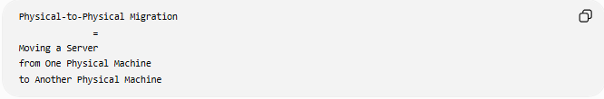
Physical-to-Physical Migration
=
Moving a Server
from One Physical Machine
to Another Physical Machine

📚 What is a Physical Server?
# Source: AI Source: Provided by: [Data Path: Persons Table -> ID Column: 1, Name_En Column: Motasem Essam] -> From: [ChatGPT] on [6/7/2026]
A physical server is a real hardware computer dedicated to hosting applications and services.
Examples:
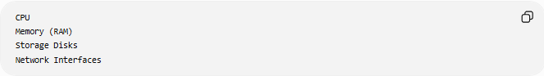
CPU
Memory (RAM)
Storage Disks
Network Interfaces

🔍 Physical-to-Physical Migration Overview
# Source: AI Source: Provided by: [Data Path: Persons Table -> ID Column: 1, Name_En Column: Motasem Essam] -> From: [ChatGPT] on [6/7/2026]
Before
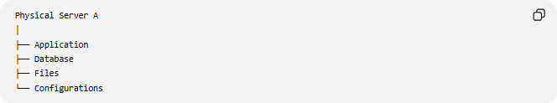
Physical Server A
│
├── Application
├── Database
├── Files
└── Configurations

After
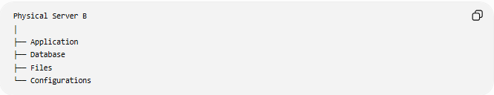
Physical Server B
│
├── Application
├── Database
├── Files
└── Configurations

Everything is transferred to the new machine.

🏗️ Common Scenarios

1️⃣ Hardware Upgrade
# Source: AI Source: Provided by: [Data Path: Persons Table -> ID Column: 1, Name_En Column: Motasem Essam] -> From: [ChatGPT] on [6/7/2026]
Old Server
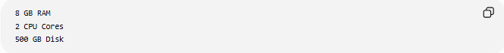
8 GB RAM
2 CPU Cores
500 GB Disk

New Server
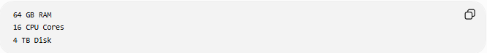
64 GB RAM
16 CPU Cores
4 TB Disk

Purpose:
Higher Performance
More Capacity

2️⃣ Data Center Relocation
# Source: AI Source: Provided by: [Data Path: Persons Table -> ID Column: 1, Name_En Column: Motasem Essam] -> From: [ChatGPT] on [6/7/2026]
Before
Data Center A

After
Data Center B

Purpose:
Better Facilities
Lower Costs

3️⃣ Hardware Replacement
# Source: AI Source: Provided by: [Data Path: Persons Table -> ID Column: 1, Name_En Column: Motasem Essam] -> From: [ChatGPT] on [6/7/2026]
Replace aging equipment.
Before
10-Year-Old Server

After
Modern Server

Benefits:
Reliability
Vendor Support

🛠️ Real-World Example
# Source: AI Source: Provided by: [Data Path: Persons Table -> ID Column: 1, Name_En Column: Motasem Essam] -> From: [ChatGPT] on [6/7/2026]
Before Migration
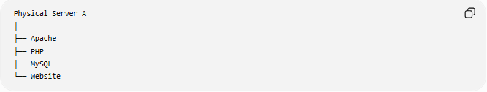
Physical Server A
│
├── Apache
├── PHP
├── MySQL
└── Website

Problems:
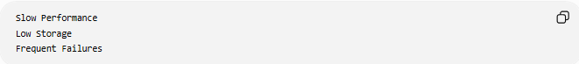
Slow Performance
Low Storage
Frequent Failures

Migration
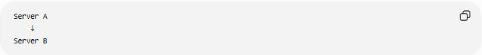
Server A
↓
Server B

After Migration
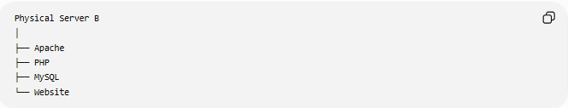
Physical Server B
│
├── Apache
├── PHP
├── MySQL
└── Website

Benefits:
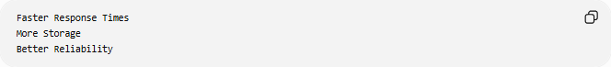
Faster Response Times
More Storage
Better Reliability

🔄 Migration Lifecycle
# Source: AI Source: Provided by: [Data Path: Persons Table -> ID Column: 1, Name_En Column: Motasem Essam] -> From: [ChatGPT] on [6/7/2026]
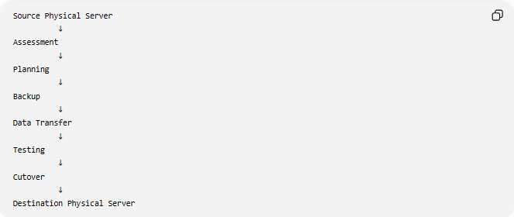
Source Physical Server
↓
Assessment
↓
Planning
↓
Backup
↓
Data Transfer
↓
Testing
↓
Cutover
↓
Destination Physical Server

📦 What Gets Migrated?
# Source: AI Source: Provided by: [Data Path: Persons Table -> ID Column: 1, Name_En Column: Motasem Essam] -> From: [ChatGPT] on [6/7/2026]
Applications
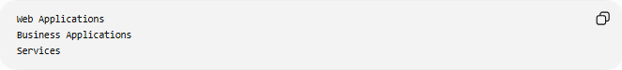
Web Applications
Business Applications
Services

Databases
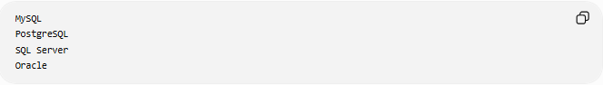
MySQL
PostgreSQL
SQL Server
Oracle

Files
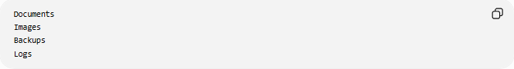
Documents
Images
Backups
Logs

Configurations
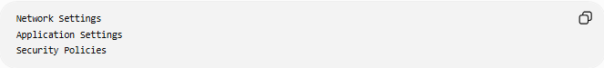
Network Settings
Application Settings
Security Policies

🌍 Example Migration
# Source: AI Source: Provided by: [Data Path: Persons Table -> ID Column: 1, Name_En Column: Motasem Essam] -> From: [ChatGPT] on [6/7/2026]
Source Server
Server A
IP: 192.168.1.10
Runs:
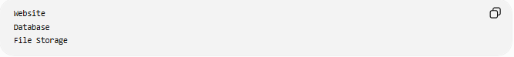
Website
Database
File Storage

Destination Server
Server B
IP: 192.168.1.20

Migration
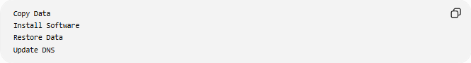
Copy Data
Install Software
Restore Data
Update DNS

Result
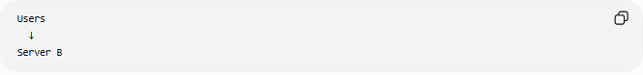
Users
↓
Server B

⚠️ Common Challenges
# Source: AI Source: Provided by: [Data Path: Persons Table -> ID Column: 1, Name_En Column: Motasem Essam] -> From: [ChatGPT] on [6/7/2026]
Downtime
Applications may need to be stopped during migration.

Hardware Differences
New hardware may require:
Driver Updates
Configuration Changes

Data Transfer Time
Large servers may contain:
Terabytes of Data
requiring many hours to migrate.

Network Reconfiguration
Changes may be needed for:
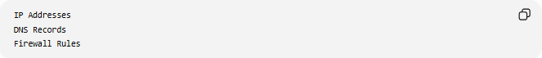
IP Addresses
DNS Records
Firewall Rules

Compatibility Issues
Applications may behave differently on new hardware.

✅ Benefits
# Source: AI Source: Provided by: [Data Path: Persons Table -> ID Column: 1, Name_En Column: Motasem Essam] -> From: [ChatGPT] on [6/7/2026]
Better Performance
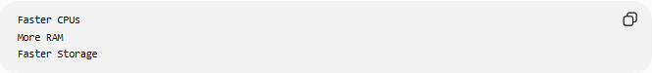
Faster CPUs
More RAM
Faster Storage

Increased Reliability
New Hardware
Lower Failure Rates

Larger Capacity
More Storage
More Processing Power

Improved Support
Vendor Support
Warranty Coverage

Future Growth
Scalable Infrastructure

📊 Physical-to-Physical vs Physical-to-Virtual
# Source: AI Source: Provided by: [Data Path: Persons Table -> ID Column: 1, Name_En Column: Motasem Essam] -> From: [ChatGPT] on [6/7/2026]
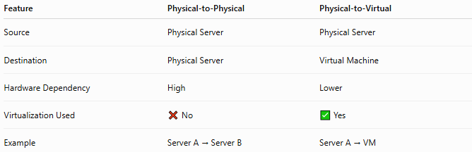
Feature | Physical-to-Physical | Physical-to-Virtual
Source | Physical Server | Physical Server
Destination | Physical Server | Virtual Machine
Hardware Dependency | High | Lower
Virtualization Used | ❌ No | ✅ Yes
Example | Server A → Server B | Server A → VM

Physical-to-Physical
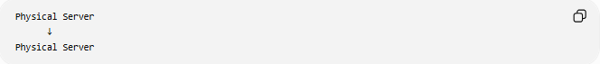
Physical Server
↓
Physical Server

Physical-to-Virtual
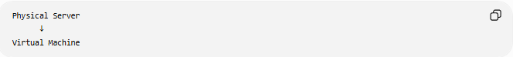
Physical Server
↓
Virtual Machine

🛠️ Common Tools
# Source: AI Source: Provided by: [Data Path: Persons Table -> ID Column: 1, Name_En Column: Motasem Essam] -> From: [ChatGPT] on [6/7/2026]
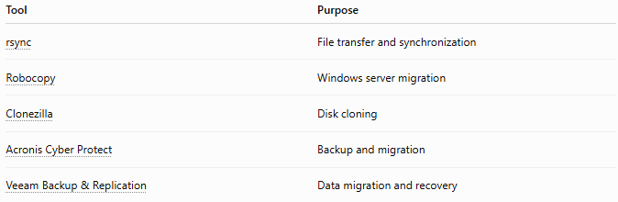
Tool | Purpose
rsync | File transfer and synchronization
Robocopy | Windows server migration
Clonezilla | Disk cloning
Acronis Cyber Protect | Backup and migration
Veeam Backup & Replication | Data migration and recovery

🧠 Simple Analogy
# Source: AI Source: Provided by: [Data Path: Persons Table -> ID Column: 1, Name_En Column: Motasem Essam] -> From: [ChatGPT] on [6/7/2026]
Imagine moving a business office.
Before
Old Office Building
Contains:
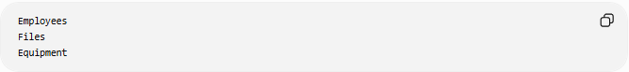
Employees
Files
Equipment

Migration
Move Everything

After
New Office Building
The business remains the same, but it operates in a newer and better building.
Physical-to-Physical server migration works the same way:
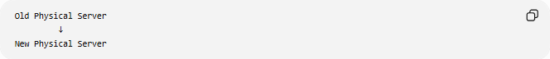
Old Physical Server
↓
New Physical Server
while preserving applications, data, and services.

🧭 Summary
# Source: AI Source: Provided by: [Data Path: Persons Table -> ID Column: 1, Name_En Column: Motasem Essam] -> From: [ChatGPT] on [6/7/2026]
Physical-to-Physical (P2P) Migration is a type of server migration where applications, databases, files, and configurations are moved from one physical server to another physical server. It is commonly performed for hardware upgrades, server replacement, capacity expansion, or data center relocation. The primary benefits are improved performance, reliability, storage capacity, and long-term hardware support while maintaining existing application functionality.

